https://www.investintech.com/prod_a2d.htm:
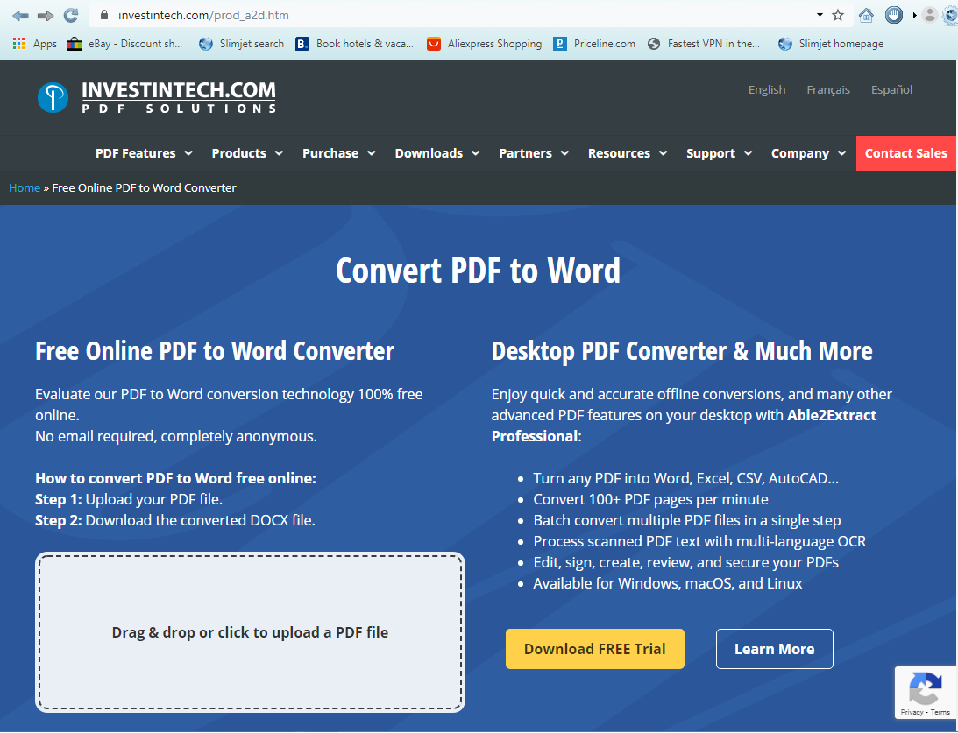

https://www.investintech.com/prod_a2d.htm:


